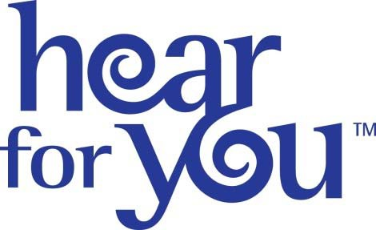
INSERT YOUR PRACTICE LOGO AND CONTACT INFORMATION HERE

(INSERT DATE) CONTACT: (INSERT NAME AND CONTACT FOR
MEDIA ADVISORY MEDIA CONTACT

(INSERT NAME OF YOUR PRACTICE) TO HOST HEAR FOR YOU, AN INTERACTIVE OPEN HOUSE TO RAISE AWARENESS ABOUT HEARING HEALTH TO CELEBRATE BETTER HEARING MONTH

(Insert your City and State)— On (Insert Date and Time of Activity), (Insert Name of Your Practice) will celebrate (National Hearing Protection Month or Better Hearing Month) by hosting Hear for You, a one‐day open house featuring hands‐on education and critical information about hearing loss, including strategies to protect yourself from preventable hearing loss. This event is free of charge to the general public and designed for anyone interested in learning more about the importance of optimizing their hearing over a lifetime.

What: (Insert Name of Practice) presents Hear for You
When: (Insert Date)
(Insert Hours)
Where: (Insert Street Address) (Insert City, State and Zip)
Why: To raise awareness about the importance of hearing health and to provide information about hearing loss prevention and available treatments.

Featuring: Hear for You will feature interactive activities that showcase the workings of the inner ear, types of hearing loss, causes of hearing loss, and tips for preventing hearing loss. Attendees will have an opportunity to get a first‐hand look (and listen) at how sound is measured and will also have the opportunity to participate in a pure‐tone hearing screening and a written hearing inventory to determine if and when a comprehensive diagnostic hearing evaluation is recommended.

Contact: (Insert Contact Information)

